# **INSERTION SORT**

## **Time Complexities**

**Worst Case Complexity: O (n2)**

Suppose, an array is in ascending order, and you want to sort it in descending order. In this case, worst case complexity occurs.

Each element has to be compared with each of the other elements so, for every nth element, (n-1) number of comparisons are made.

Thus, the total number of comparisons = n*(n-1) ~ n2

**Best Case Complexity: O (n)**

When the array is already sorted, the outer loop runs for n number of times whereas the inner loop does not run at all. So, there are only n number of comparisons. Thus, complexity is linear.

**Average Case Complexity: O (n2)**

* It occurs when the elements of an array are in jumbled order (neither ascending nor descending).

**Space Complexity**

* Space complexity is O(1) because an extra variable key is used.

**Insertion Sort Applications**

The insertion sort is used when:

* the array is has a small number of elements
* there are only a few elements left to be sorted

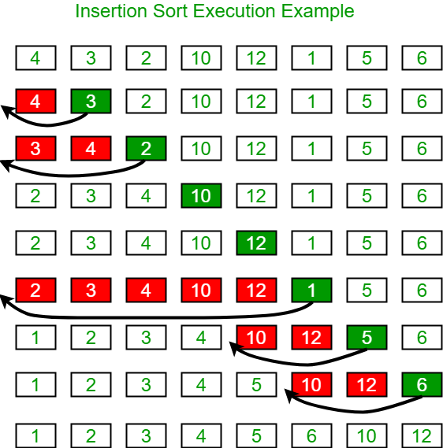

# **SELECTION SORT**

## Complexity

|  |  |
| --- | --- |
| Cycle | Number of Comparison |
| 1st | (n-1) |
| 2nd | (n-2) |
| 3rd | (n-3) |
| ... | ... |
| last | 1 |

**Complexity = O (n2)**

Also, we can analyze the complexity by simply observing the number of loops. There are 2 loops so the complexity is n*n = n2.

## **Time Complexities:**

**Worst Case Complexity: O (n2)**

* If we want to sort in ascending order and the array is in descending order then, the worst case occurs.

**Best Case Complexity: O (n2)**

* It occurs when the array is already sorted

**Average Case Complexity: O (n2)**

* It occurs when the elements of the array are in jumbled order (neither ascending nor descending).

The time complexity of the selection sort is the same in all cases. At every step, you have to find the minimum element and put it in the right place. The minimum element is not known until the end of the array is not reached.

## **Space Complexity:**

**Space complexity is O (1)** because an extra variable temp is used.

**Selection Sort Applications**

The selection sort is used when:

* a small list is to be sorted
* cost of swapping does not matter
* checking of all the elements is compulsory
* cost of writing to a memory matters like in flash memory (number of writes/swaps is O(n) as compared to O(n2) of bubble sort)

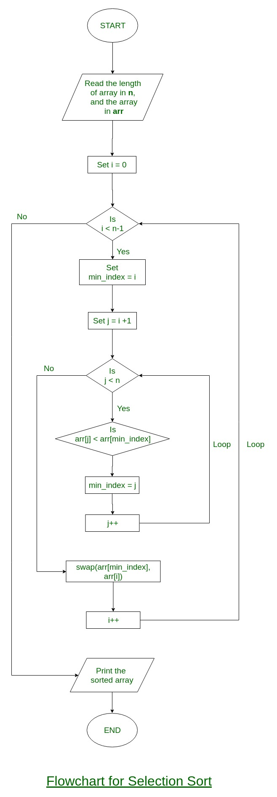

DSA